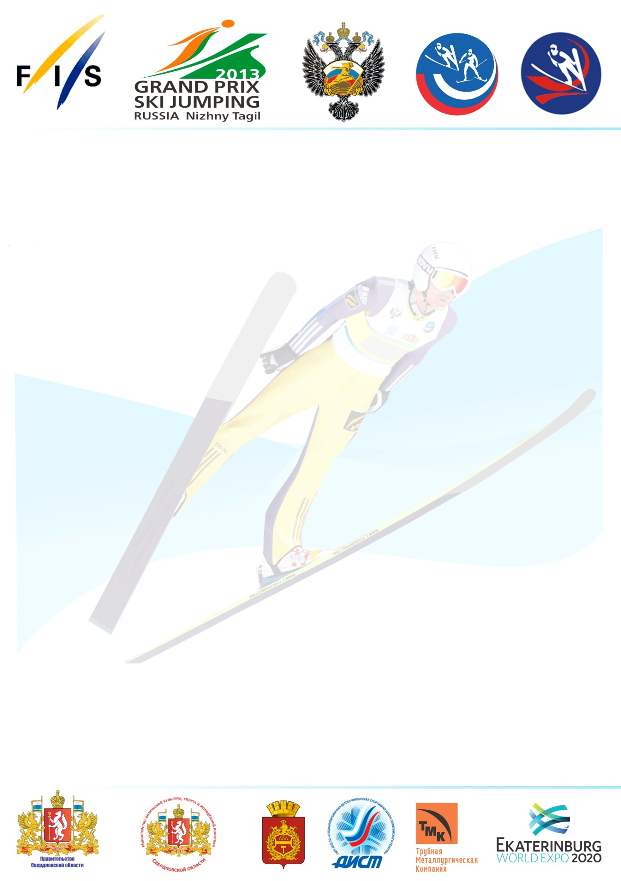

September, 12th Thursday |  | Arrival Day
September, 13th Friday |  | 10.30 - TCM meeting Men  12.00 - Official Training HS 106 Men 2 Jumps  14.00 - Qualification Men HS 106  17.00 - Team Captains Meeting Ladies  18.30 - Official Training HS 106 Ladies 2 Jumps  19.15 - Qualification Ladies HS 106  20.00 – 1st Competition Round Ladies HS 106  Following Final Round Ladies HS 106
September, 14th Saturday |  | 11.00 - Qualification (or Trial Round) Ladies HS 106  12.00 - 1st Competition Round Ladies HS 106  Following Final Round Ladies HS 106  19.00 –Trial Round Men HS 106  20.00 1st Competition Round Men HS 106  Following Final Round Men HS 106
September, 15th Sunday |  | 10.00 – Official Training Men HS135 2 Jumps  12.00 – Qualification Men HS135  19.00 - Trial Round Men HS135  20.00 -1st Competition Round Men HS 135  Following Final Round Men HS 135
September, 16th Monday |  | Day of departure

